HANDS-ON 3
JavaScript ES6+ & DOM Manipulation

Task 1: ES6+ Syntax Practice
29. Create a data.js file and export a const array of 5 course objects, each with id, name, code, credits, and grade properties.
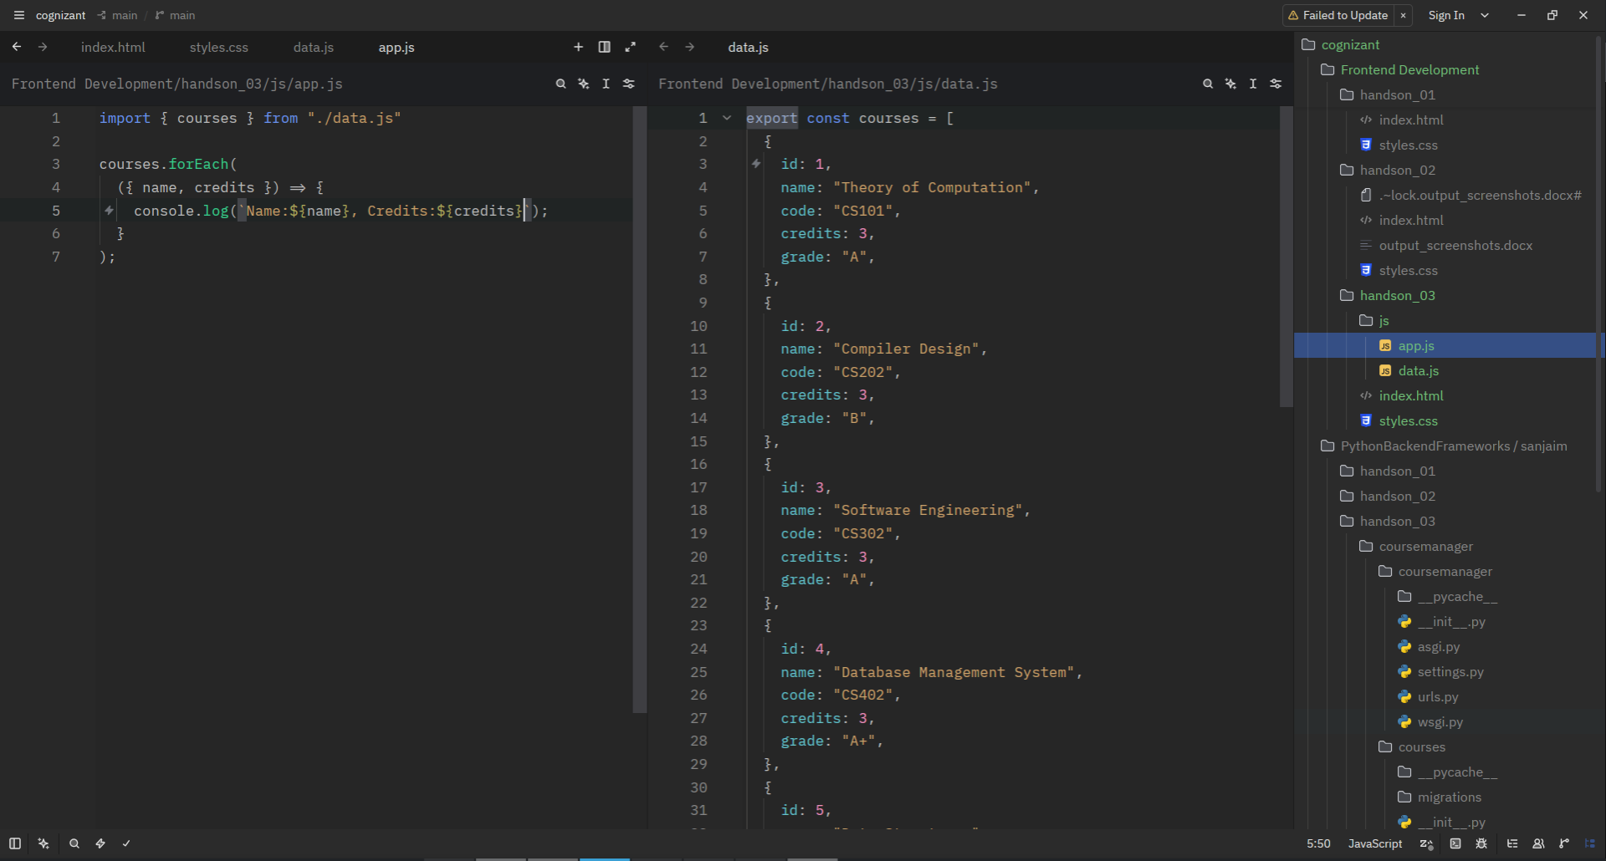
30. In app.js, import the array using ES6 import. Use destructuring to extract name and credits from each course in a loop.

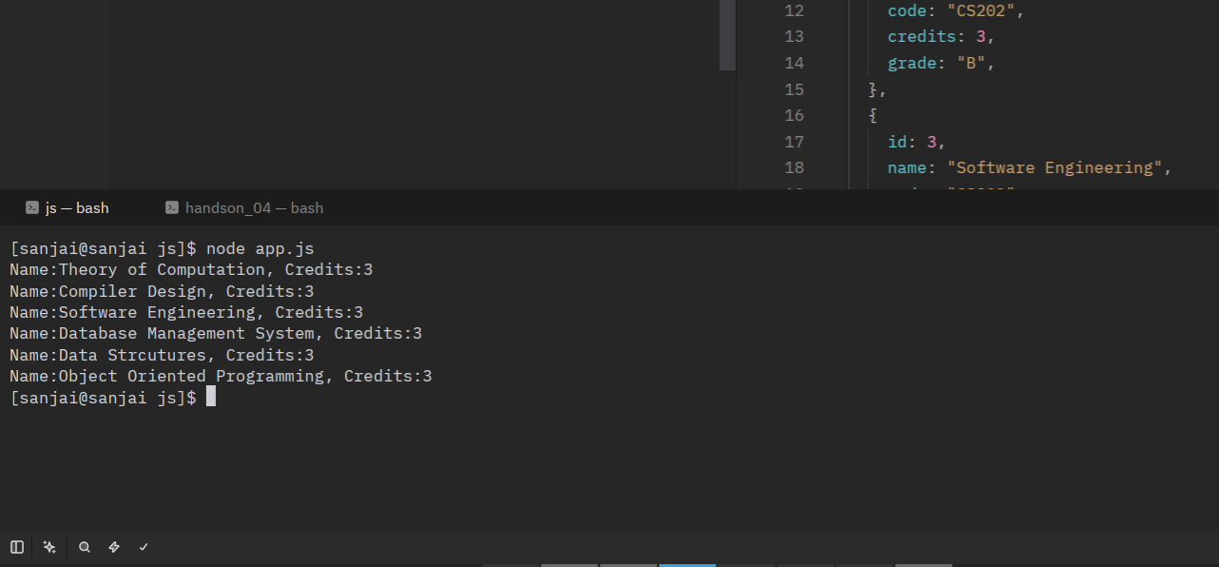
31. Use Array.map() to create a new array of strings formatted as 'CS101 — Data Structures (4 credits)'.Log the result.
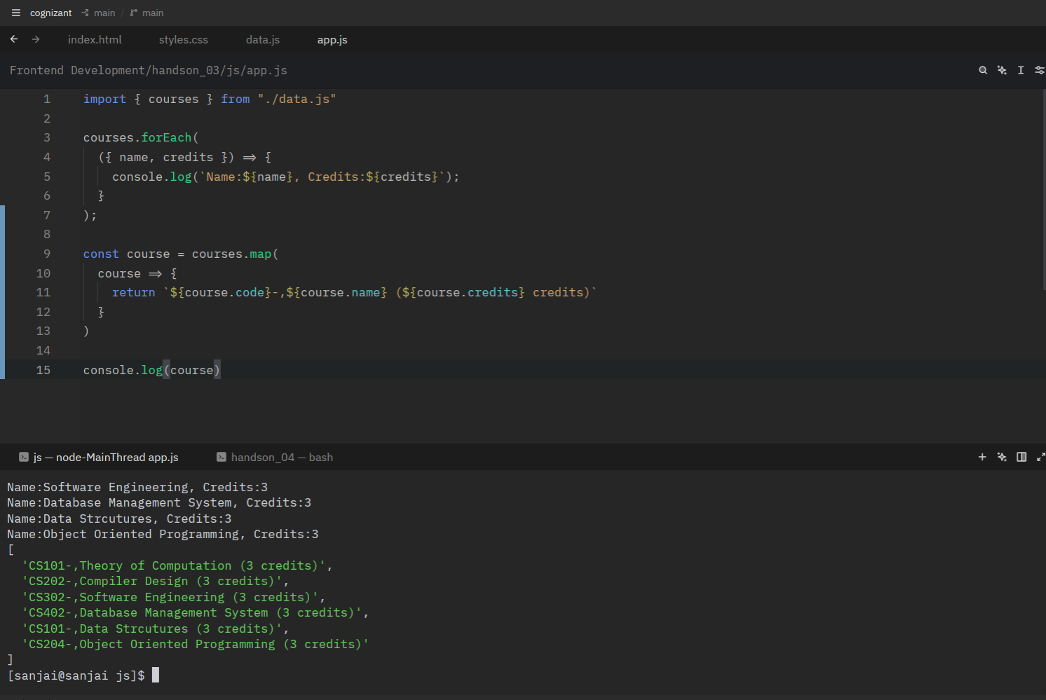

32. Use Array.filter() to get only courses with credits >= 4. Log the count.
